**MAWLANA BHASHANI SCIENCE AND TECHNOLOGY UNIVERSITY**

SANTOSH, TANGAIL-1902



DEPARTMENT OF INFORMATION AND COMMUNICATION TECHNOLOGY

**Course Title: Digital Logic Design Lab**

**Course Code: ICT-2104**

**Lab Report on:** Implementation of JK Flip-Flop

**Lab Report No: 05**

|  |  |
| --- | --- |
| Submitted By | Submitted To |
| Name: Kuldip Saha Mugdha  ID: IT22018  2nd Year, 1st Semester  Session: 2021-2022  Dept. of ICT, MBSTU | Dr. Muhammad Shahin Uddin  Professor  DEPARTMENT OF INFORMATION AND COMMUNICATION TECHNOLOGY  MAWLANA BHASHANI SCIENCE AND TECHNOLOGY UNIVERSITY |

**Date of Performance:**

**Date of Submission:**

**Experiment No:** 05

**Experiment Name:** Implementation of JK Flip-Flop

**Objective:** To implement and verify the functioning of a JK flip-flop using a digital IC and understand its behaviour through the construction of its truth table.

**Materials Required:**

* Breadboard
* Power supply (5V DC)
* Connecting wires
* IC 7473 (JK Flip-Flop)
* Clock pulse generator (or manual clock)
* LEDs (to observe outputs)
* Resistors (220Ω)
* Switches (for inputs J and K)
* Multimeter (optional)

**Procedure:**

**1. Understanding the JK Flip-Flop:**

- The JK flip-flop is a sequential logic circuit with two inputs, J and K, and two outputs, Q and Q'. It is a refinement of the SR flip-flop that eliminates the indeterminate state.

**2. Circuit Setup:**

- Place the IC 7476 on the breadboard.

- Connect the power supply to the IC: pin 7 to ground and pin 14 to +5V.

- Identify the J and K inputs on the IC (e.g., pin 1 and pin 2).

- Connect the clock input to a clock pulse generator or a manual clock circuit (pin 3).

- Connect the Q and Q' output pins (e.g., pin 5 and pin 6) to LEDs through resistors to observe the output states.

- Attach push-button switches to the J and K inputs to change their values manually.

- Verify connections using a multimeter if needed.

**3. Operation:**

- Apply different combinations of inputs to J and K while providing clock pulses.

- Observe the output (Q and Q') changes on the LEDs.

- Record the outputs for each input combination over several clock cycles.

**Diagram:**

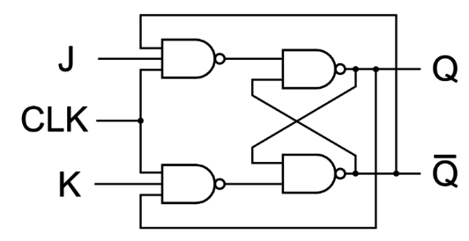

**Truth Table:**



**Discussion:**

The JK flip-flop is an essential sequential logic device with applications in counters, memory units, and state machines. In this experiment, we successfully implemented the JK flip-flop using the IC 7473 and observed its characteristic behaviour.